The effort - one of the big environmental problems

Name: Larisa Druga
Age: 16 years
Name of school unit: "Mihai Eminescu" national College Suceava
Country of origin, county, municipality: Romania, Suceava, Suceava.
Effort is one of the major problems in our times. Every day, more and more trees are being knocked down for all sorts of reasons. With the deforestation of so many forests, other environmental problems such as climate change, the disappearance of certain species of fauna and flora specific to certain areas and others are also beginning.
To understand why deforestation is a problem, we need to know what this phenomenon means. Deforestation is the cutting of trees on a given area without being followed by its regeneration. Deforestation is not only about cutting, but also about removing roots and bushes.
The causes leading to an increase in the number of trees felled in forests around the world are subsistence farming, accounting for 48%, commercial agriculture, about 32% and logging, 14%. 5% of logging is done for fuel.
Some of the negative effects of deforestation are environmental degradation, the formation of the greenhouse effect leading to global warming, the loss of scientific possibilities, the disappearance of certain plant or animal species and others.
Firstly, in nature, there is a system that must be in balance for the good of our planet. If the forest disappears, the soil formed over 1000 years would disappear in about 10 years The disappearance of the water leads to very large floods, as there would be no source of water.
Secondly, the disappearance of forest deforestation would have a huge impact on the climate. This impact is due to the greenhouse effect, which is formed by the accumulation of carbon dioxide in the atmosphere. Green trees and plants absorb carbon dioxide and remove oxygen. People, animals and birds breathe oxygen and produce carbon dioxide. The decayed trees also release carbon dioxide. Deforestation would lose balance and global warming would affect our home.
One solution could be to implement greening and afforestation activities dedicated to all citizens several times a year. Public institutions, with the help of kindergartens, schools, schools, schools, organize activities targeting both children, who will learn to keep the environment clean, and adults, who would be more attentive to their actions. Another solution would be to give money to citizens who report illegal deforestation. Another solution is to cut old forest and plant young trees to keep the forest young and healthy.
For example, last year, in April, we went to an afforestation activity in the forest-based Pătătăuti, where we planted over 100 oak pups, Tei.
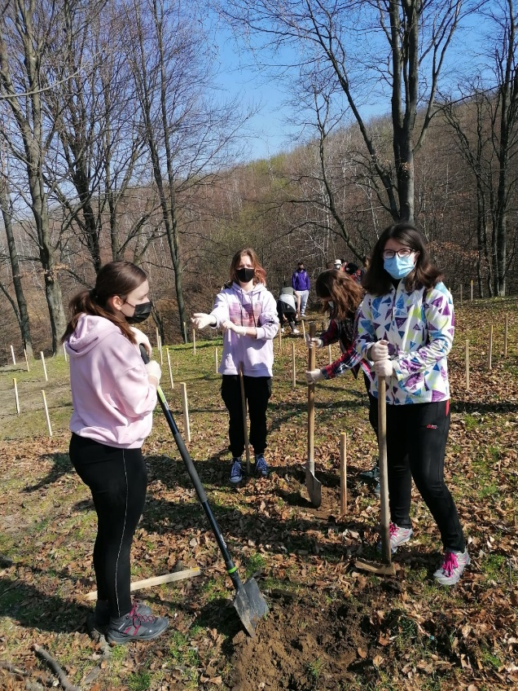
Photos from afforestation since 2021, own archive:
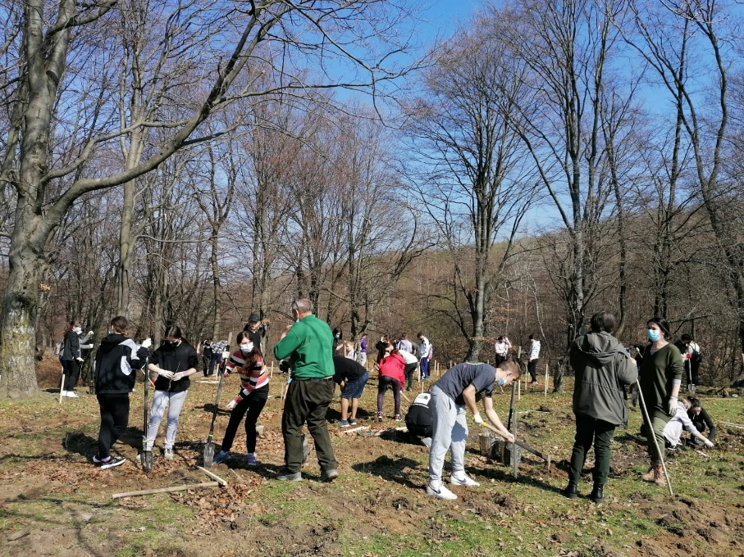
The forest is the home of many species of animals and plants, but also a source of fuel and food for us. The forest is a sacred monument left by mother nature to rejoice our hearts and eyes, and we must take care of it. Any small step is a change, so let's protect our house!

